Machine learning (ML) is a method of using a computer to inspect features from example sets and then form what is called classifiers from these features. There are are variety of machine learning (ML) algorithms which have developed over the past few decades. In 1983 Machine Learning: The AI Approach was published which is really the foundation for today's ML algorithms. Rather than a book it was a volume of compiled research papers discussing the diverse ML algorithms and approaches to constructing them. [1]

The problem which is being aimed to be solved in this project is a moving slider puzzle. What we want to optimize is the amount of blocks moved to reach a final desired placement of blocks. Figure 1 shows a possible solution using an algorithm known as hill climbing search. This algorithm examines nodes near the current state and then takes the path which has the lowest cost.

In Figure 1 the cost is the sum of the distances each block needs to take to get into the final positions from the current state positions depicted in the final state. Figures 2 and 3 shows how to calculate a distance in the way that was just mentioned.

Now there are a few machine learning methods to implement the hill climbing search, among them being the four groups of unsupervised learning, supervised learning, deep learning and reinforcement learning. Supervised learning in this case is not too useful as it uses predefined/known labels which in this case would mean a solution that requires something like a dataset of completed steps from different start states to the final states.

There are 99 = 387.42 * 10E6 possible states for a nine by nine board and generally NN  which quickly grows large and hence brute force computation will be slow.

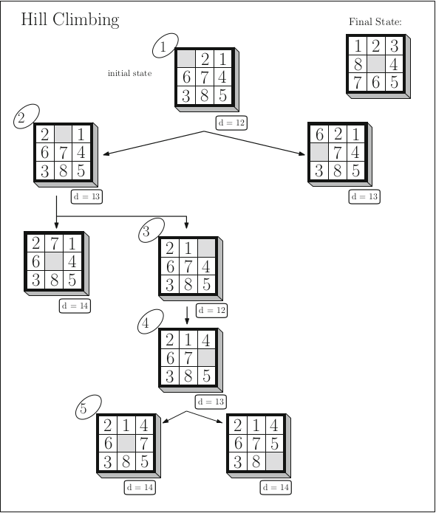  
Figure 1 “Hill climbing. Circled integers indicate the order in which the search states are visited.

d is a state’s distance from the final state as calculated by the given evaluation function. Ties are broken randomly” [1]

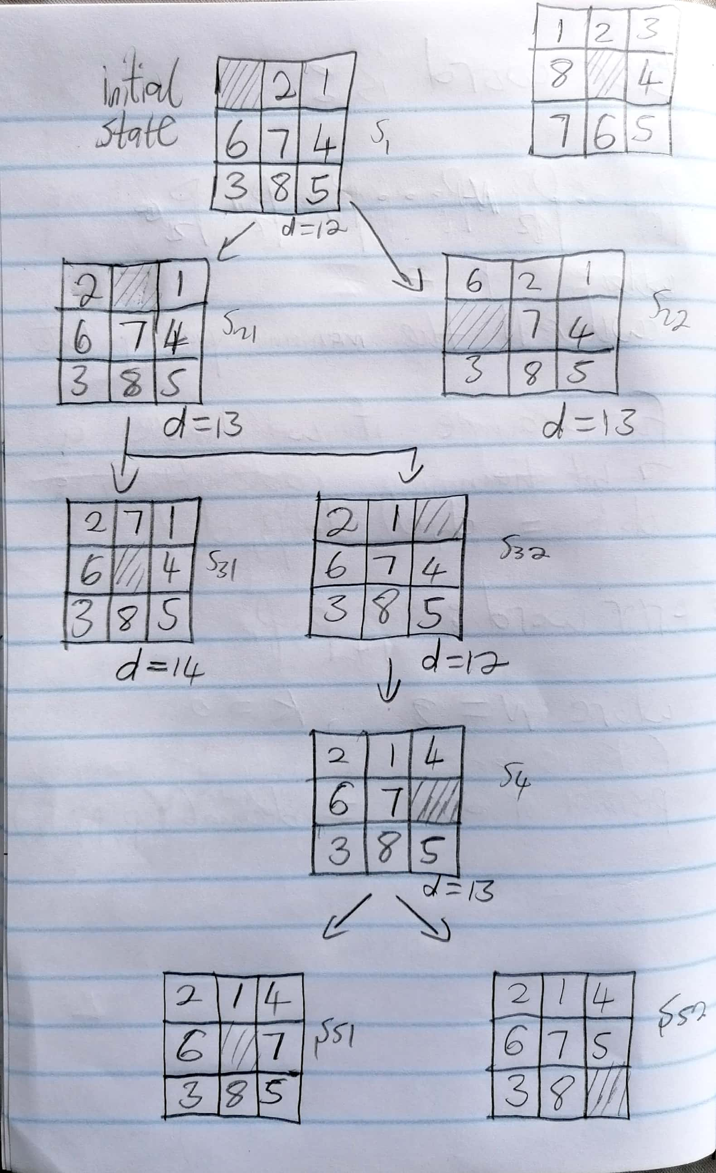  
Figure 2 Defining state variable names next to each state to make referencing in the text easier

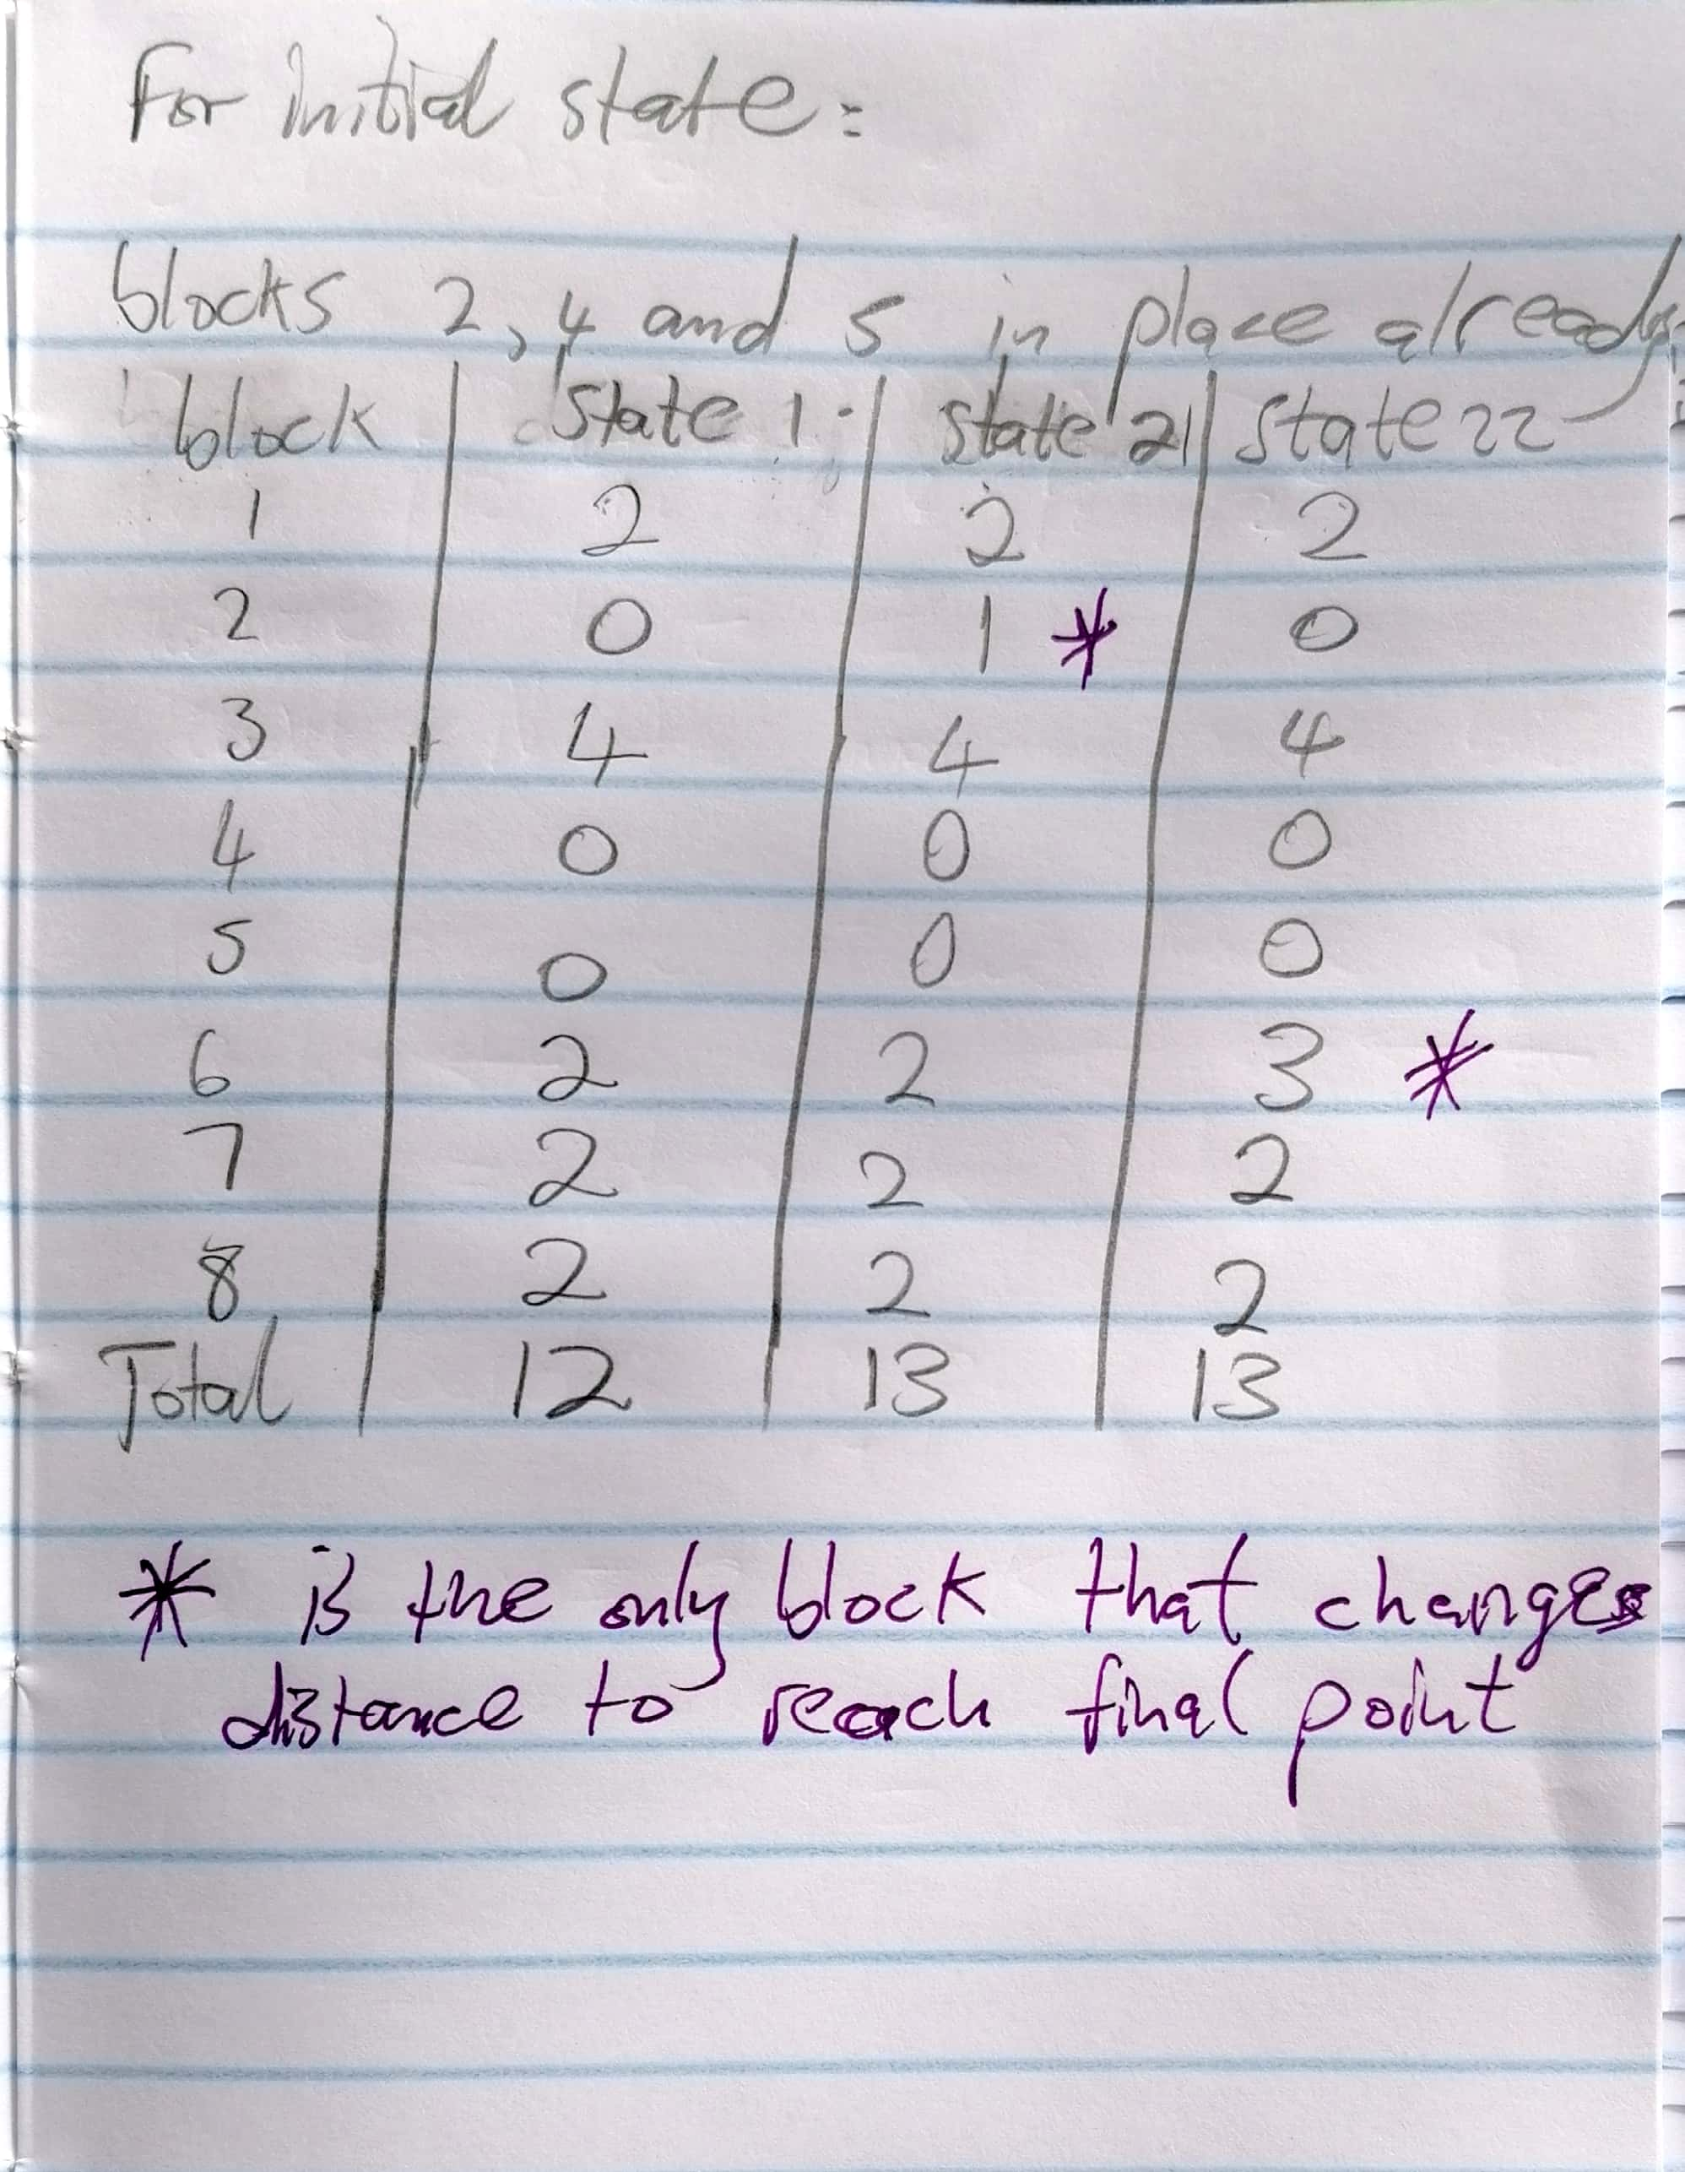  
Figure 3 Calculations for the distances in states s1, s21, s22 using state names as defined in Figure 2

# References

An Introduction to Machine Learning Second Edition, Miroslav Kubat, Springer International Publishing AG 2015, 2017 [1]